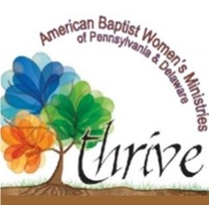
American Baptist Women’s Ministries of Pennsylvania And Delaware
E.W.E. Scholarship Fund Scholarship Application
The E.W.E. Scholarship purpose is to: Support learning, encouraging, and leadership for ABW. If you are seeking scholarship funds, please complete and mail this application to the Spiritual Enrichment Coordinator. Only one scholarship to be issued to an individual annually.
First Name: ______________________________________________________________________________________
Last Name _______________________________________________________________________________________
Address: _________________________________________________________________________________________
City: ____________________________________________________________________________________________
State: __________________________ Zip: ______________
Phone: ____________________________ Cell Phone: ____________________________
Email: ___________________________________________________________________
Church Name and City: _____________________________________________________________________________
What position(s) do you hold in your church: (Moderator, Deacon, Trustee, Sunday School Teacher, Financial Officer, Clerk, Secretary, ABWM Officer, etc.) _________________________________________________________________
Name of the educational institution you will attend: _____________________________________________________
Address of the educational institution: ________________________________________________________________
Name of the course / courses you intend to take and the cost: _____________________________________________
Amount you are requesting (not to exceed $300 or more than 25% of the overall cost of the course / courses: ______
Applicants should be:
• A member of an American Baptist Church in PA or DEL
• Currently holds a leadership position at the church or within ABWMPAD
• Registered to attend an event or course that is in line with the scholarship purpose
• Able to provide documentation of the cost of the event or course
• Willing to use the skills or knowledge gained to advance the mission of the American Baptist Church and/or ABWMOPAD
Return Completed Application to:
Jodie Vasbinder, Spiritual Enrichment Coordinator
PO Box 55, Hillsdale, PA 15746

